FOR SALE: SPECIAL OFFER

APARTMENTS IN KILELESHWA

🔵 Studio Apartments [270sqft] Kes. 3.8M

🔵 2 Bedrooms Ensuite [1130sqft] Kes. 9.4M

🔵 2 Bedrooms Ensuite Plus SQ [1184sqft] Kes. 10.3M

🔵 3 Bedrooms Ensuite [1292sqm] Kes. 12.5M

🔵 4 Bedrooms Ensuite [1356sqm] Kes. 13.3M

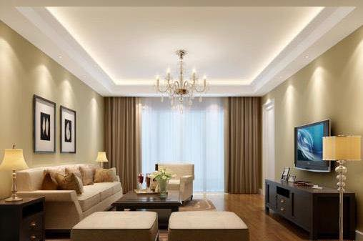

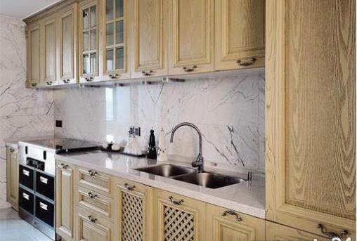

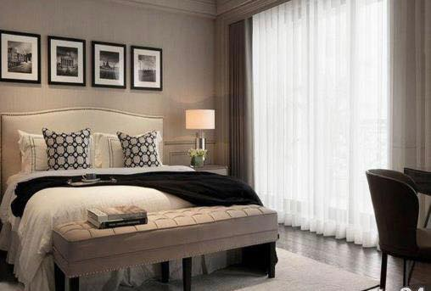

FEATURES   
🔵Away from Riparian Road  
🔵 High Quality Finishes   
🔵Spacious Master Bedroom with Shower Cubicle  
🔵Spacious Kitchen with Enough Cabinets  
🔵Solar Panels connected to Water Heaters (Saving on Electricity)  
🔵All Bedrooms with enough Wardrobes  
🔵Spacious Living & Dining Area  
🔵Kitchen with Fitted Cabinets  
🔵Bedrooms with Wooden Floor

AMENITIES

🔵Adequate Natural Light  
🔵High Speed Lifts  
🔵Intercom  
🔵Children Play Area  
🔵Gardens Area  
🔵Ample Parking  
🔵Landscaped Gardens  
🔵Fully Equipped Gym  
🔵Solar Heater  
🔵Backup Generator  
🔵Backup Borehole

CONTACTS

For more on this property and/or viewing:

Contact person: BTE Properties

Contact number: 0722 931254

Contact email: joycenyagah@gmail.com